Machine Learning – Tutorial

Gradient Boosting for Classification

Kokila Sivakumar – 24058234

Gradient Boosting
Boosting
Boosting is a special type of Ensemble Learning technique that works by combining several _weak learners(predictors with poor accuracy)_ into a strong learner(a model with strong accuracy). This works by each model paying attention to its predecessor’s mistakes.
The two most popular boosting methods are:
- Adaptive Boosting(you can read my article about it here)
- Gradient Boosting
We will be discussing Gradient Boosting.

What is Gradient Boosting?
Gradient Boosting is a highly effective ensemble learning method that consistently performs well on a wide range of classification problems. It has gained popularity because it can handle complicated datasets, capture subtle patterns, and deliver highly accurate predictions. For anyone aiming to strengthen their machine learning skills, understanding how Gradient Boosting works is an essential step.
In this guide, we focus on building Gradient Boosting models using scikit-learn’s GradientBoostingClassifier. We will look at the main ideas behind the algorithm, explore the key parameters that influence its behaviour, and walk through a practical example to show how the model is trained and evaluated.
Gradient Boosting constructs a strong predictive model by combining many weaker models—typically small decision trees. Unlike methods such as Random Forests, which generate multiple trees independently, Gradient Boosting builds trees one at a time, with each new tree specifically trained to correct the errors made by the previous ones. Over multiple iterations, this approach steadily improves the model’s performance.

How Gradient Boosting Works (Rewritten)
The fundamental concept behind Gradient Boosting is an iterative learning process where each new model focuses on the errors left unresolved by earlier models.

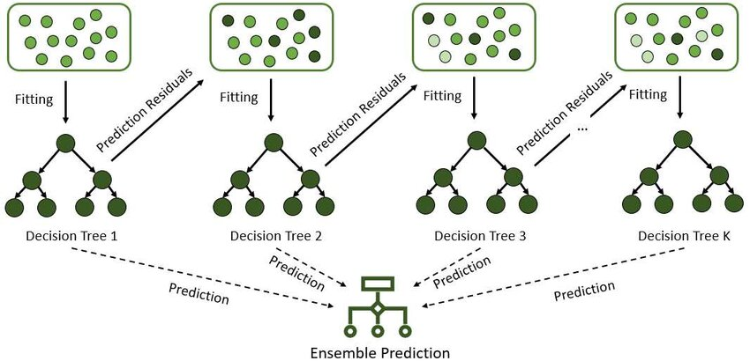
Here’s how it works:
- Start with a simple baseline model
Usually this is just a constant value, such as the mean prediction for the dataset.
- Compute the residuals (errors)
These residuals represent the gap between the model’s predictions and the true target values.
- Train a weak learner on the residuals
A small decision tree is fitted to explain these errors rather than the original target.
- Update the overall model
The predictions from this new tree are added to the existing model to reduce the remaining error.
- Repeat the process
More trees are added sequentially, each improving the model slightly until a stopping condition is reached (such as a fixed number of iterations or no further improvement).
This step-by-step correction mechanism allows Gradient Boosting to steadily reduce prediction errors and ultimately produce a powerful and accurate model.

Key Parameters in Gradient Boosting (Rewritten)
Scikit-learn, a popular machine learning library in Python, provides a robust implementation of Gradient Boosting through its GradientBoostingClassifier. This class allows you to easily apply this powerful algorithm to your classification problems.
To use Gradient Boosting effectively, it’s important to understand the main parameters that shape how the algorithm learns.
🔹 n_estimators
This defines the number of boosting stages (trees) added to the model.
- More trees → potentially higher accuracy
- Too many trees → risk of overfitting
- Common range: 100–300
🔹 learning_rate
Controls how much influence each new tree has on the final model.
- Small learning rate = slower but more stable learning
- Large learning rate = faster training but may overfit
- Usually set between 0.01 and 0.1
The learning rate and number of trees work together.
A smaller learning rate often requires more trees.
🔹 max_depth
Determines the depth of each decision tree.
- Shallow trees (depth 1–3) are preferred
- They prevent overfitting and allow gradual learning
🔹 subsample
Fraction of the dataset used to train each tree.
- Value < 1 introduces randomness
- Helps prevent overfitting
- Example: subsample = 0.8
Together, these parameters allow you to fine-tune the trade-off between accuracy, speed, and generalisation.

Step-by-Step: Fitting a GradientBoostingClassifier
Best Practices and Tips
To get the most out of your GradientBoostingClassifier models:
- Feature Engineering: The quality of your features heavily influences model performance. Invest time in creating meaningful features.
- Cross-Validation: Always use cross-validation during hyperparameter tuning to get a reliable estimate of your model”s performance and prevent overfitting to the validation set.
- Early Stopping: GradientBoostingClassifier in scikit-learn doesn”t directly support early stopping during fit() as some other libraries do (e.g., XGBoost). However, you can implement it manually by monitoring performance on a validation set and stopping training when performance no longer improves, or use parameters like n_iter_no_change if available in newer versions for specific loss functions.
- Monitor Overfitting: Keep an eye on the training vs. validation score. A large gap indicates overfitting. Adjust max_depth, n_estimators, learning_rate, and subsample to mitigate this.

